**MEDICAL STORE MANAGEMENT**

**A Project Report**

***Submitted by***

**DEVANSH GUPTA C037**

**VED CHAWAN C018**

**CHAITANYA ASARKAR *C009***

***Under the Guidance of***

## Prof. KRISHNA SAMDANI

## B. TECH INTEGRATED

## COMPUTER ENGINEERING

## At



**MUKESH PATEL SCHOOL OF TECHNOLOGY, MANAGEMENT AND ENGINEERING**

**DECLARATION**

We, **Devansh Gupta, Ved Chawan and Chaitanya Asarkar** Roll No. **C037, C018, C009** B.Tech Integrated (Computer Engineering), understand that plagiarism is defined as anyone or combination of the following:

1. Un-credited verbatim copying of individual sentences, paragraphs or illustration (such as graph diagrams, etc.) from any source, published or unpublished, including the internet.
2. Un-credited improper paraphrasing of pages paragraphs (changing a few words phrases, or rearranging the original sentence order)
3. Credited verbatim copying of a major portion of a paper (or thesis chapter) without clear delineation of who did wrote what. (Source: IEEE, The institute, Dec. 2004)
4. I have made sure that all the ideas, expressions, graphs, diagrams, etc., that are not a result of my work, are properly credited. Long phrases or sentences that had to be used verbatim from published literature have been clearly identified using quotation marks.
5. I affirm that no portion of my work can be considered as plagiarism and I take full responsibility if such a complaint occurs. I understand fully well that the guide of the seminar/ project report may not be in a position to check for the possibility of such incidences of plagiarism in this body of work.

Signature of the Student:

Name: Devansh Gupta Ved Chawan Chaitanya Asarkar

Roll No: C037 C018 C009

Place: Mumbai

Date:

**Table of Contents**

|  |  |  |
| --- | --- | --- |
| **CHAPTER NO.** | **TITLE** | **PAGE NO.** |
|  | Abstract |  |
| 1. | INTRODUCTION | 6 |
| 2. | TOOLS & TECHNIQUES | 9 |
| 3. | SIMULATIONS & RESULTS | 15 |
| 4. | CONCLUSION | 21 |
| 5. | FUTURE WORK | 22 |
| 6. | REFRENCES | 23 |

**ABSTRACT**

The project is titled as **“MEDICAL STORE MANAGEMENT SYSTEM”** for monitoring and controlling the system at a medical store. The” **MEDICAL STORE MANAGEMENT SYSTEM”** is a medicine stock inventory system that can be used in medical stores. This code stores detail of medicine purchase and sell stock. WE as young coders can maintain the placements of the orders their deliveries according to the consumer. The main purpose is effectively and easily handling of medical data and its management. This system about identifies the discount provided to bulk orders. This system has such a algorithm that it takes details like brand value and the number of order done and provide discount according to it. This system also provide and give delivery beneficial to the customers .This program is also mainly build to wide scale the medical store owners business. Here we have loyalty patch which not only increases the sales but also give loyal and regular customers

The project “**MEDICAL STORE MANAGEMENT SYSTEM”** is developed in C++, which mainly focuses on basic operations in store like checking for the available stock and updating the stock. It features a familiar and well thought-out, an attractive user interface, combined with various searching insertion and output capabilities.

**INTRODUCTION**

Today the world’s most forward looking agencies are trying to provide more reliable and accurate services in their field, offering services to customers and employees with all the available choices in their interest. Every medical shop is nowadays is trying to computerize its activities to provide better services to its customers. The aim is to automate its existing manual system by the help of computerized equipment’s and full-fledged computer software, fulfilling their requirements, so that their valuable data/information can be stored and can be easily accessed.

The **MEDICAL STORE MANAGEMENT SYSTEM** is also a step towards offering more or less the same features. This system organizes their daily activities like billing, tablets numbers their pricing, stock details and more.

The **MEDICAL STORE MANAGEMENT SYSTEM** is an application project developed for medical shops. This system is field concerned with purchasing and selling medicines, maintaining their inventory. It requires more time when done manually. The purpose of this project is to reduce time consumption and human effort, save time but increase the work efficiency. This code also provides a user friendly interface as well.

The code has seven functionalities

CHECKING STOCKS

TAKE ORDER

MENU

HOME DELIVERY

BULK ORDER DISCOUT

LOYALTY BATCH

Bill and payment

NEW MEDICINE DATABASE

* **Take order**-

This system allows the medical store staff or the casher to enter the medical details that the user wants to purchase. This not only is done to make things easy but also a great step in the modern and the digital world. It helps the casher to communicate well as well as safe time. This system also help to maintain records and ensures that things are going smooth and systematically

* **BILL AND PAYMENT-**

So here you will be provided with the bill which directly linked to the order you have done. The number of order, name of the medicine and the price to be paid will be reflected on the bill section. Then it will show up the total amount to be paid, you have to enter and payment will be successful. This is one of the best features in this system and U.I is really appreciating.

* **Delivery-**

With the modern and fast growing world having all the services at the doorstep, this system is also going hand in hand by also providers such facilities .This program have such an algorithm that it take distance details and provide the delivery flare and details.

This not only gives great accessibility to the owner to grow its business staying within the budget but also give customer great and easy facility.

* **Loyalty batch**:

This is the most important as well as the one of the main features of this system.

In this we have three tier i.e. GOLD TIER, SILVER TIER AND GREEN TIER.

So the customers which are loyal and regularly shops get discounts on their loyalty.

We categorise customers as –

GOLD TIER Making purchase more than 100 times.

SILVER TIER Making purchase more than 50 times.

GREEN TIER Having purchase between 0 and 20 times.

This system ensures that customers are regular at the store, also providing records and data for the owner. This is the great feature that not only wide large scale business but also creates interest of the customers.

This is one of the great step towards **speed business**

* **Stock details**:

Through the system the casher /owner will be able to monitor and edit the stocks available in the store. This is great step towards modern management system .This program provides great help to the casher/owner to update its stocks and the buying customers. So whenever the owner of the store is having low or will be out of stock soon, it will soon get the notification regarding the same. Storing data in this system is way too convenient and a smart way. It helps the owner to avoid confusion and mess.

* **BULK ORDER DISCOUNT:**

This is the one of the main features in this system. This system has such an algorithm that it take details of the brand making bulk order and staying within the budget providing a bulk order discount to the brand. It is convenient and profitable for both the ends.

This is the system which not only will attract the bulk order brands but also will give a good percentage of profit to owner helping to wide scale its business.

* **New medicine database :**

So basically if the owner /casher doesn’t have the medicine required by the user in the stock, then he can add the medicine name in the database and store it .This is make sure that next time he will be having required medicines. This is provide a greater brand value of the store. It will make thongs easy to manage.

**TOOLS & TECHNIQUES**

**TOOLS-**

1. **CODE::BLOCKS**

Code::Blocks is a free C, C++ and Fortran IDE built to meet the most demanding needs of its users. It is designed to be very extensible and fully configurable. Using a plugin architecture, its capabilities and features are defined by the provided plugins. (Fig2.0)

1. **Note pad**

Notepad is a simple text editor for Microsoft Windows and a basic text-editing program which enables computer users to create documents. It was first released as a mouse-based MS-DOS program in 1983, and has been included in all versions of Microsoft Windows since Windows 1.0 in 1985. Fig (2.1)

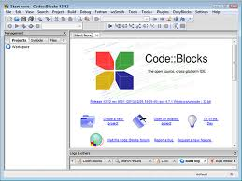 

Fig 2.0 Fig 2.1

**TECHNIQUES-**

* **Switch case –**

A **switch case** is used test variable equality for a list of values, where each value is a **case**. When the variable is equal to one of the **cases**, the statements following the **case** are executed. A break **statement** ends the **switch case**.

Syntax (fig2.2)-

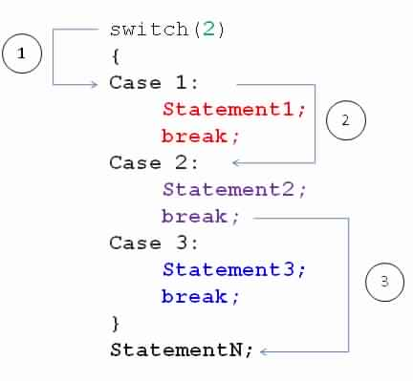

Fig 2.2

* **Nested switch case-**

These are a substitute for long if statements that compare a variable to several integral values

* The switch statement is a multi-way branch statement. It provides an easy way to dispatch execution to different parts of code based on the value of the expression.
* Switch is a control statement that allows a value to change control of execution.

Syntax (fig 2.3):

switch (n)

{

case 1: // code to be executed if n = 1;

break;

case 2: // code to be executed if n = 2;

break;

default: // code to be executed if

// n doesn’t match any cases

}

Fig 2.3

* **If else –**

**If else statements** in **C++** is also used to control the program flow based on some **condition**, only the difference is: it's used to execute some **statement** code block **if** the expression is evaluated to true, otherwise execute **else statement** code block.

* **Nested if else-**

It is always legal to **nest** if-else statements, which means you can use one if or else if statement inside another if or else if statement(s).

## Syntax-

If (condition)

{

If (condition)

{

Statements;

Statements;

Statements;

}

}

* **While loop**

In most computer programming languages, a while loop is a control flow statement that allows code to be executed repeatedly based on a given Boolean condition. The while loop can be thought of as a repeating if statement. (Fig 2.4)

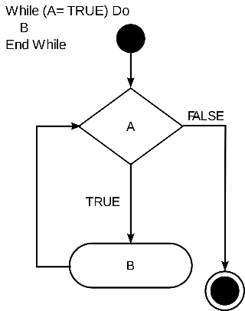

Fig 2.4

* **Object Oriented Programming**

 is a paradigm that provides many concepts such as inheritance, data binding, polymorphism etc. The programming paradigm where everything is represented as an object is known as truly **object-oriented programming** language. (Fig 2.5)

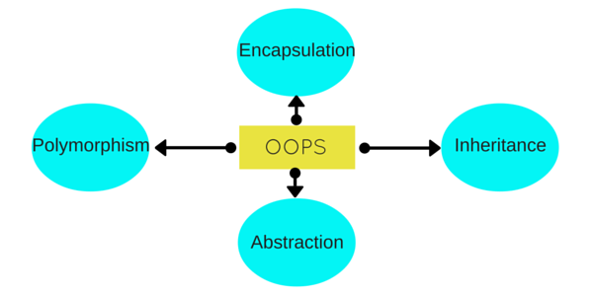

* **Header files –**

The **files** that tell the compiler how to call some functionality (without knowing how the functionality actually works) are called **header files**. They contain the function prototypes. They also contain Data types and constants used with the libraries. We use #include to use these **header files** in programs.

1. **#include <iostream>**

**#include** is known as a pre-processor directive, which is used to load files..

**<>** indicate the start and end of file name to be loaded you can use " " quotes too instead of <>

Where is the file iostream.h?  
This file is located somewhere in your include path. They include path indicates the directories on your computer in which to search for a file, if the file is not located in the current directory.

Why do I need to include iostream.h?  
In this case, iostream.h is a file containing code for input/output operations. You need to include iostream.h so that the compiler knows about the word cout, which appears a couple of lines below.

1. **#include <iomanip>**

Iomanip is a standard library used for formatting your output. Based on where and how you want to redirect output of your program you can choose to format it to make it look more presentable. For example say if you want to print a table of positive integers in n rows x 3 columns format.

1. **#include <stdlib.h>**

**stdlib**.**h** is the header of the general purpose standard library of C programming language which includes functions involving memory allocation, process control, conversions and others. It is compatible with **C++** and is known as cstdlib in C++. The name "**stdlib**" stands for "standard library"

1. **#include <string>**

In order to use the **string** data type, the **C++ string** header <**string**> must be included at the top of the program. Also, you'll need to **include** using namespace STD; to make the short name **string** visible instead of requiring the cumbersome std::**string**.

1. **#include <windows.h>**

**windows**.**h** is a **Windows**-specific header file for the C and C++ programming languages which contains declarations for all of the functions in the **Windows** API, all the common macros used by **Windows** programmers, and all the data types used by the various functions and subsystems.

1. **#include <stdio.h>**

Input and Output operations can also be performed in **C++** using the C Standard Input and Output Library (cstdio, known as **stdio**.**h** in the C language). This library uses what are called streams to operate with physical devices such as keyboards, printers, terminals or with any other type of files supported by the system.

1. **#include <conio.h>**

C/C++ Language Symbol # is known as pre-processor,

**include** is a directory and all the header files like stdio.h, **conio**.h are kept there.

**conio**.h stands for "Console Input Output Header File”, which manages input/output

on controlled based applications.

1. **#include <fstream>**

file streams **include** two member functions specifically designed to read and write binary data sequentially: write and read . The first one (write) is a member function of ostream (inherited by ofstream ). And read is a member function of stream (inherited by **ifstream**). Objects of class **fstream** have both.

|  |
| --- |
| **SIMULATIONS & RESULTS** |
|  |
| Fig (3.1) |
| First page that appears is to be welcome screen. Clicking ahead we will move to fig (3.2) |
| Fig (3.2)  Fig (3.2) shows the menu of the program. Here there are 7 option and 8th one is to exit the system.  Choosing the option we directly throw you in the respective category . |
| Fig 3.3  Here from fig 3.2 we clicked option 1 ,and we entered int taking order category.  When taking order menu is opened ,we see a table menu of the medicine availble in the medical shop.  Casher will enter the order number ,name ,no.of orders respectively . Current date will automatic pop up .  Casher will enter the number next to the medicine name and you order will be placed. After placing order  You will get the bill and payment can be done choosing option 7. |
| Fig 3.4  In fig3.4 we see the menu that will open up when in select option 2 from the main menu. Here we see there are three categories .By entering the name , the branch name and the total time you made purchased respectively ,it will show which category you belong. |
| Fig 3.5  By selecting option 3 from the main menu we will come up to this. Here you need to enter details and agorithm will do its work and will give you the maximum discount that shop can provide on bulk orders. |
| Fig 3.6  Delivery methods are shown in the figure 3.6 SO here you need to enter the city you want to get your delivery. After that give distance detials and you will be getting delivery information i.e is delivery possible or not ,if yes then what will be the cost of home delivery . |
| Fig 3.7  By entering option stocks on the main menu ,you will be here, Here you need to enter the category of stocks you want to check or edit.    Fig 3.8  Here you will be getting 2 options to check the stocks and to edit the stocks. |

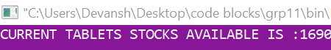 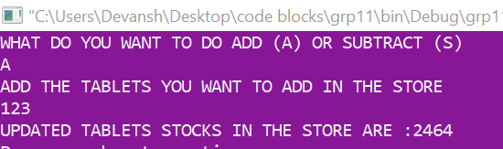

Fig 3.10 fig 3.9

Here they will total number of stocks available Here you can edit the stocks.

Will be shown. Updated stocks will be shown

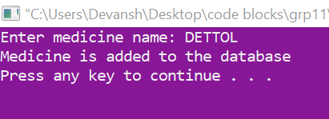

Fig 3.11

By clicking the 6th option you will be here. Here you can add the medicine to your database and case access it later.

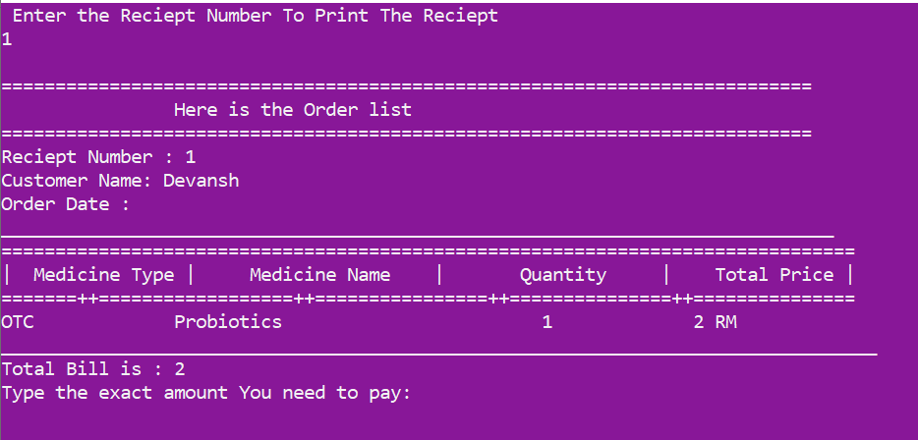

Fig 3.10

Here it will show you the order bill and payment. The orders done by the customers in option 1 which will reflected here in the form of bill. After that you will be shown up exact money to pay and according to have to pay.

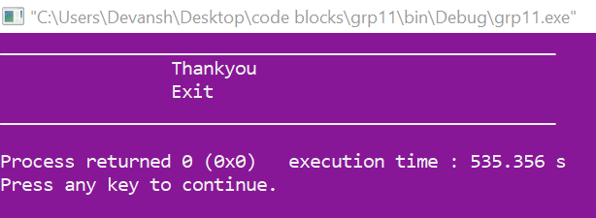

Fig 3.13

By clicking option 7, you will exit the system.

**Conclusion**

By using “**Medical** **store management system**”, the orders can be easily tracked and the report acts as a proof. The order will be taken systematically and will be saved safely in the database rather than manually through paper work. It requires less time and space to save the order details. Database can be cleared yearly or monthly according to the company.

The system provides an easy way for the operator to interact with the database and to manipulate the data in the database.

Medical systems enable you to deal with your business so you can concentrate on your patients. They offer three pharmacy management systems worked to suit an extensive variety of business objectives:

Enterpriser—The cloud-facilitated pharmacy management programming that augments store operations, brings together patient and medical data and backings patients health programs.

Pharmacy—The reasonable, facilitated pharmacy management programming that procedures solutions oversees pharmacy operations and improves patient care.

Pharmaserv— The demonstrated, on-site pharmacy management framework that completely incorporates doctor prescribed solution administering, pharmacy operations, and patient clinical services.

**Future work**

1. There will be only one database for more than one store .All thing will be mange from one database only
2. We will try to add features like cashback offers according to affordability of the owner.
3. Expiry date reminder , The medicine that are added to the database and are kept in the store get expire, the owner will get the notification for the same
4. We will also try to add messaging notifier to the customer about the festival scheme and offers.
5. We will also try to improve on security facilities in this system.
6. Last but not the least we will try to make the U.I more easy and accessible.

**Reference –**

1. <https://www.youtube.com/channel/UCRIWTSgd7hGtZhx4RYoASEg> 
2. <https://www.slideshare.net/anikettherock/medical-store-management-system-56045886>
3. <https://www.geeksforgeeks.org/> 
4. <https://www.youtube.com/channel/UCF7BExjT2zH_mmyqOB139Dg>



END

x--------------------------------------x-------------------------------------------x